Computer Systems and Internet Technologies - COMP1589

HTML & CSS Frameworks
Lab

SUMMARY
Building web pages can take a long time and often we need to re-use elements across multiple pages or projects. Furthermore most projects require the same starting place, so we’d rather start from there than from scratch.
This is where frameworks come in to support, sometimes we may also refer to them as boilerplates when they simply provide a starting point but no tools per se. They can form the basis of our projects and help speed up development.
In this lab we’ll look at getting a HTML boilerplate and applying a CSS framework to it, allowing us to craft elements much quicker than we otherwise would.

OBJECTIVES
- To get comfortable with the concept of boilerplating HTML code
- To become familiar with utilising CSS libraries and frameworks
- To have a basic understanding of using build tools such as Node Package Manager to allow us to use more advanced CSS and JS technologies in a simpler manner

TASK 1 - Boilerplating
Step 1
You’ll have noticed that across your projects your HTML code looks very familiar, we always have the same structure up to the body tags generally and we often have a CSS file and sometimes a JS file.
To save ourselves the time of creating these elements over and over again we can use an off-the-shelf boilerplate that other developers have created for us. This is great for when we are creating simple HTML websites, when we move to using frameworks such as Vue or React these have their own boilerplate systems specifically for them.
To get started let’s download a common HTML5 boilerplate from the aptly named HTML5 Boilerplate website.
Go ahead and click the big download button and then extract the zip folder to the folder you are working from.
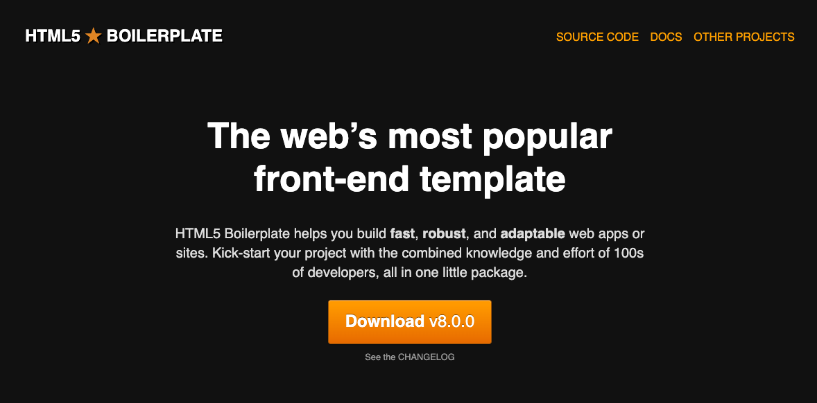

Step 2
Now open your whole working directory in Visual Studio Code, you can do this by dragging the directory into VS Code. It should look something like this when you’ve opened it:
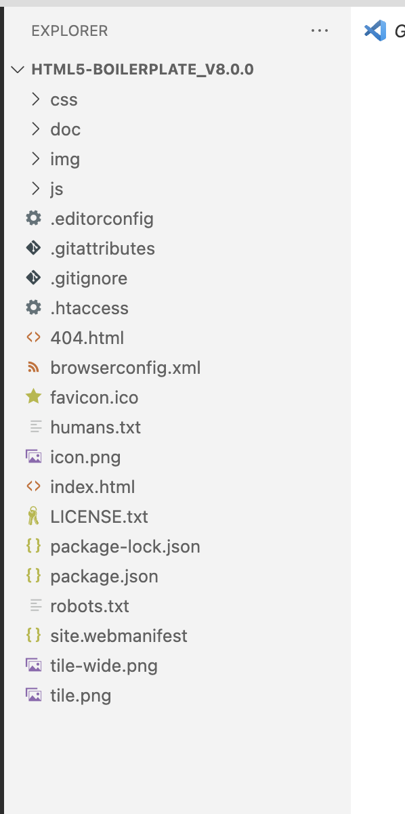
You can see we have a lot of files here, so let’s tidy up what we don’t need first of all. You can safely delete the following files:
- .htaccess - this is used within Apache servers, not needed locally
- humans.txt - this is a text file used to indicate who has worked on the project, not necessarily needed unless you wish to keep it
- robots.txt - this an indexing rules file for search engines, not needed whilst we’re just working locally
- 404.html - configured in our .htaccess this will be the page people see if they try to access a URL that doesn’t exist

Now let’s talk through the remaining files:
.editorconfig
A file to store our editor settings, it is supported by many code editors and IDEs, including Visual Studio. It's a portable component that travels with your code, and can enforce coding styles even outside of Visual Studio.
.gitattributes
Similar to the editorconfig file but for git, defines the settings and attributes for using git within this repository.
.gitignore
This tells git what files to ignore from version control, in here you’ll find our distribution folder and node_modules which we’ll come to later. Additionally you’ll see “.cache” which is sometimes generated by code editors when it is generating code completion for that project.
browserconfig.xml
A configuration file for Microsoft users if they save your website as a desktop tile, useful when making progressive web apps (PWA).
favicon.ico
A key file for any respectable website, it is the icon that shows in the browser tab to indicate what website you are on. This is automatically loaded by the browser, you don’t need to define it in your HTML.
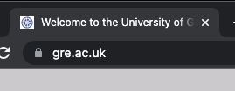
index.html
Our core HTML file. Index is the default file a server/browser looks for in a directory.
LICENSE.txt
The licence for using this boilerplate/repository.
package-lock.json
This lists our third party inclusions using Node Package Manager, this is the list of what should be installed and specifics of that install (what exact versions).
package.json
Similar to our package-lock file however this is our definition, whereas the lock file is generated by the package manager. We use this to define elements of our project, how scripts should be run and what packages we are using with roughly what version we want. The version we define here is a pattern that tells us we want at least, or at most, X version - whereas the lock specifies exactly what version was installed.
site.webmanifest
A browser configuration file that defines how the website should work as a Progressive Web App.
Step 3
Now that you’ve got an understanding of the core files, spend a few minutes reading through the HTML file so that you have a basic understanding of what it’s doing.
The key takeaways are:
- Within the head we link to our stylesheets, the normalize stylesheet is there to reset the browser default styles - ensuring that our base look is the same in all browsers/devices.
- Within the bottom of the body we load in our Javascript files, this is because they are known as load blocking - meaning that the page won’t render until these are loaded - so we put them at the end to ensure the page is visible as fast as possible
- We have a modernizr file, this relates to our “no-js” class on our HTML tag. Modernizr adds classes to your HTML tag, and provides a JS interface, to determine what features we can/can’t use in this version of the browser. Go ahead and open the HTML page in your browser and inspect the source, you’ll notice that the HTML element has loads of classes applied to it now (also notice this is different if you view source, because this is the generated source)
- Finally at the end of the file we have Google Analytics tags, we can remove both of these script tags as we won’t be using any analytics yet

And there you have it, that is your boilerplate ready to go and be used - you can add your styling to your main.css file and your javascript to main.js file. At this stage you may be wondering how much time that really saved, but most developers will create their own boilerplate files and when you are working with 10s of pages the time savings add up.

TASK 2 - CSS Libraries
When styling our HTML elements it can take a long time to get it just right and we often find ourselves using similar styles over and over again, for example if we have multiple button types they may all share similar styles such as rounded corners.
Additionally we will often want to use the same page structures and responsive handling across multiple projects, things like enabling elements to stack on mobile devices.
These scenarios are just some examples of where CSS libraries/frameworks come in. Depending on which you chose they can cover some or all of these and in different ways.
There are two leading libraries/frameworks for this currently, one is from Twitter known as Bootstrap and the other is called Tailwind. The main difference between these frameworks is how classes should be used, in Tailwind they go for a utility-first approach meaning that we explicitly use classes to describe the styling we want to apply - whereas bootstrap does this with less of a focus.
For example let’s look at a button in both bootstrap and tailwind.
Bootstrap
<button type="button" class="w-100 btn btn-lg btn-outline-primary">Sign up for free</button>
Tailwind
<button type="button" class="inline-flex items-center rounded-md border border-transparent bg-indigo-600 px-4 py-2 text-sm font-medium text-white shadow-sm hover:bg-indigo-700 focus:outline-none focus:ring-2 focus:ring-indigo-500 focus:ring-offset-2">Button text</button>
You can see with Tailwind that we use a significant amount of classes compared to Bootstrap, whereas Bootstrap will condense all the styling down to a few Tailwind will apply styling per class (i.e. bg-indigo-600 applies an indigo background). In that sense Bootstrap offers pre-built components that you can style, whereas Tailwind simply offers the classes you can combine to make components.
If you want to learn more about the two take a look at this article ​​Tailwind CSS vs. Bootstrap: Which is better? - Prismic.
Step 1
To get started with using a framework we will work with Tailwind first and we will utilise the Play CDN - this basically gives us the option to play around with Tailwind in a simpler way but isn’t suitable for production.
To get you familiar with reading documentation following step 1 from the Tailwind guidelines Try Tailwind CSS using the Play CDN - make sure you apply this to your boilerplate HTML. You should replace both your existing CSS link statements.
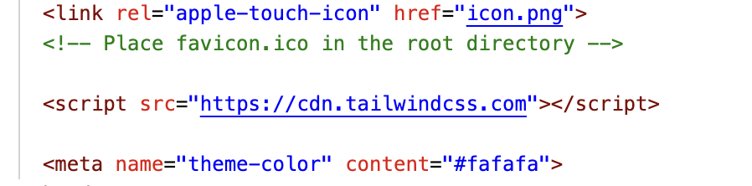
Step 2
Now have a play with applying classes to HTML elements, let’s make our text larger, bold and underlined.
<p class="text-3xl font-bold underline">Hello world! This is my Tailwind content.</p>
You can see how this is different to the “usual” approach in that we’ve used 3 distinct classes, rather than a single class that has all 3 styles associated with it. This is a utility-first design.
This sounds like a hassle and for some projects it won’t be right, and even for some preferences, however there are of course some shortcuts to this.
There is a large market out there selling pre-build HTML components, so you don’t have to worry about designing from scratch, you just need to personalise them. Tailwind even have their own official one at Tailwind UI.
Step 3
Let’s put your knowledge to the test and your ability to read documentation. I want you to try to replicate one of the badges shown at Badges - Official Tailwind CSS UI Components. Using Tailwind only.
If you get stuck there are some hints below, and if you get really stuck there is the code further below to give you the answer but please do give it a try first!
Hints
- Display - Tailwind CSS
- Align Items - Tailwind CSS
- Border Radius - Tailwind CSS
- Background Color - Tailwind CSS
- Text Color - Tailwind CSS
- Padding - Tailwind CSS
- Font Size - Tailwind CSS
- Font Weight - Tailwind CSS
Here is the answer for the blue badge, but you can of course use any colour you want - well done if you managed to get as close to this as possible, if you didn’t take a look at the code to understand what you missed.
<span class="inline-flex items-center rounded-full bg-blue-100 px-3 py-0.5 text-sm font-medium text-blue-800">Badge</span>
If you are feeling brave then try adding a hover state to the badge Background Color - Tailwind CSS, otherwise congratulations you’ve built a basic webpage with a CSS framework.
TASK 3 - Loading via NPM
If you’ve got really far ahead and wanted to challenge yourself a bit further then have a go at loading the Tailwind library via Node Package Manager. This is a tool from Node.js that lets us load in JS libraries into our code, but also as part of a set of build tools for our code such as testing, compiling, etc.
We find these packages on the official “npm” website at npmjs.com.
Before we continue, let's remove the existing NPM files as we’re not using them, so delete your current package.json and package-lock.json files.

Step 1
Install tailwind, following the instructions on their website in their step 1 let’s install Tailwind into our project.
Installation - Tailwind CSS
You’ll need to first open your command line terminal/console:
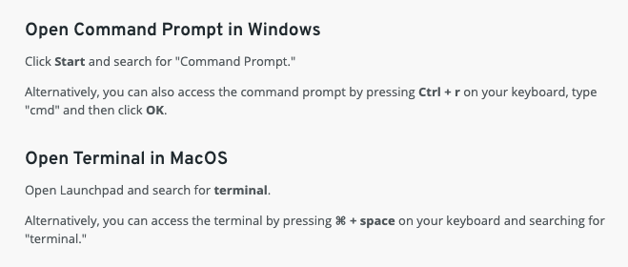
Now change the Current Working Directory to your HTML project folder - Windows/*NIX (OSX).
If you’re not sure if you’re in the correct directory in your terminal/console then you can type:
Windows
cd
*NIX(OSX)
pwd
Once you are happy that you’re in the correct directory you need to then install our library:
npm install -D tailwindcss
The “-D” indicates it’s a dev dependency, meaning we don’t use it directly in our code but we use it as a tool for our code. A security and size efficiency so we only install what we need in the correct environments.
You should see something like this which means it’s working:
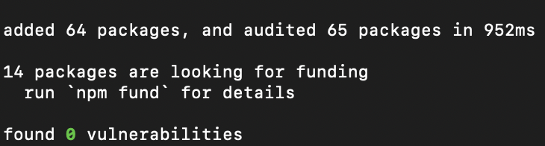
Now let’s initialise our tailwind installation with the command:
npx tailwindcss init
This should now create a tailwind.config.js file in your directory, if it hasn’t but it says it has then you’re in the wrong directory on your command line.
Step 2
Before we proceed, let's quickly create our “source” files, these are the CSS files that Tailwind will process and interact with - they differ slightly to the current CSS files we have.
Add a new directory called “src” and within that a folder called “css”, this “src” directory will be where we put our assets that will be processed by Tailwind and Node. Once you’ve created the folders add a file called “style.css” inside the “css” folder.
Your project, in Visual Studio, should now include this:

Step 3
Now we will configure Tailwind, telling it where our files are and which ones to bother about.
Open your tailwind.config.js file and copy/paste this replacing the existing “content” line. This tells Tailwind where our HTML files will live.
content: ["./**/*.html"],
Step 4
Open your newly created “style.css” file and paste the below Tailwind commands in:
@tailwind base;
@tailwind components;
@tailwind utilities;
This loads in all the default Tailwind styles for use later!
Next we need to get Tailwind running and watching our code for changes, use this command for that:
​​npx tailwindcss -i ./src/css/style.css -o ./output.css --watch
This should create a new file called output.css in your project directory, have a look at this to see what Tailwind has generated for you. It should be around 500 lines or so.
Step 5
Now we just need to link it altogether by loading in our newly generated CSS file into our project, add into your HTML replacing your current tailwind script tag.
<link href="./output.css" rel="stylesheet">
Reloading your page you should notice no difference, the styling you applied previously via Tailwind should still be visible. If you now go and add a new class such as “tracking-widest” you’ll see your command line console notice this and update your CSS, reload your page to see the change.

EXTRA
If you’ve completed all the steps above then spend some time looking at Tailwind or Bootstrap, or even looking at what libraries you can load using NPM such as Chart.js
Utility-First Fundamentals - Tailwind CSS - experiment with responsive controls, hover and even dark mode
Tailwind CSS Components - Tailwind UI - there are a few free ones to get you going
Get started with Bootstrap
Examples · Bootstrap v5.3

